P&P Racing

Newsletter No. 1 - 2022

Issue Date: 6th January 2022

Subject: Pre-Order Notice – Spark Red Bull RB16B F1 Specials 1:12th Scale

Please find below details of forthcoming items and the anticipated release date.

To pre-order, please contact P&P Racing by no later than

18:00 hours on Sunday 23rd January 2022 ACT NOW!

The cost of each model will be confirmed prior to placing an order on your behalf

Ref | Description | Barcode | Available Month
12S029 | Red Bull Racing Honda RB16B No.33 Red Bull Racing | 9580006330291 | Apr
 | Winner Dutch GP 2021
 | Max Verstappen
 | With Acrylic Cover
 | Limited 321
 | 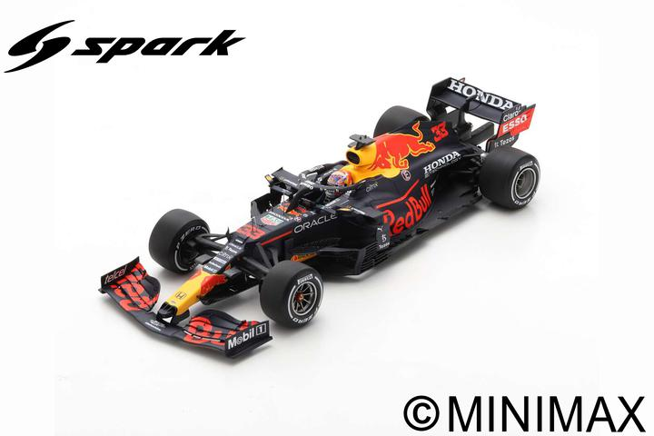
12S030 | Red Bull Racing Honda RB16B No.33 Red Bull Racing | 9580006330307 | May
 | Winner Monaco GP 2021
 | Max Verstappen
 | With Acrylic Cover
 | Limited 521
 | 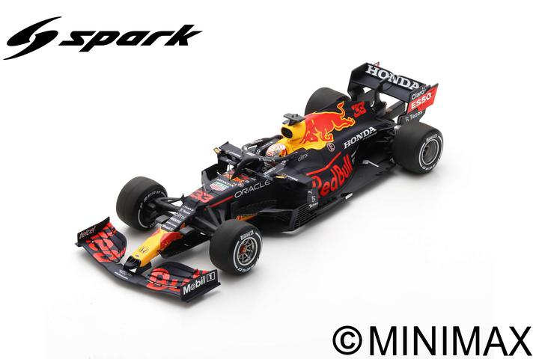
12S031 | Red Bull Racing Honda RB16B No.33 Red Bull Racing | 9580006330314 | Jun
 | 2nd Turkish GP 2021
 | Max Verstappen
 | With Acrylic Cover
 | Limited 1021
 | 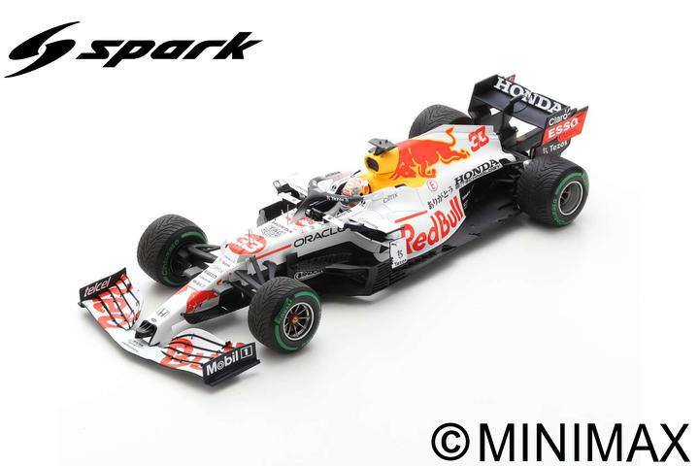
12S032 | Red Bull Racing Honda RB16B No.33 Red Bull Racing | 9580006330321 | Jul
 | Winner Abu Dhabi GP 2021
 | World Champion
 | Max Verstappen
 | With Acrylic Cover
 | Limited 2021
 | 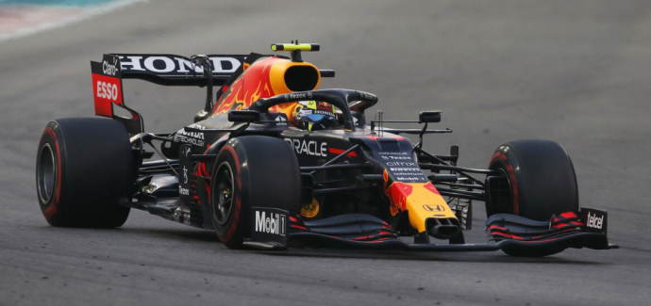

END

