P&P Racing

Newsletter No. 22 - 2021

Issue Date: 17th September 2021

Subject: Pre-Order Notice Spark 1:43 & 1:18 F1 2021 Dutch & Italian GP

Please find below details of 12 forthcoming items and the anticipated release date.

To pre-order, please contact P&P Racing by no later than

18:00 hours on Thursday 30th September 2021 – ACT NOW!

The cost of each model will be confirmed prior to placing an order on your behalf. Thank you!

1:43rd scale

 | Item No. | Scale | Description | Information
1 | S7686 | 1/43 | Red Bull Racing Honda RB16B No.33 Red Bull Racing Winner Dutch GP  2021 | 9580006976864
 |  |  | Max Verstappen | JAN 2022
 |  |  | With Pit Board
 |  |  | 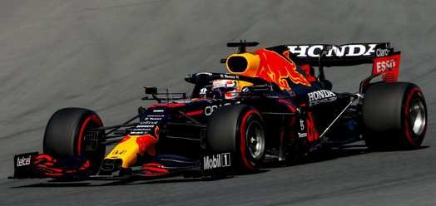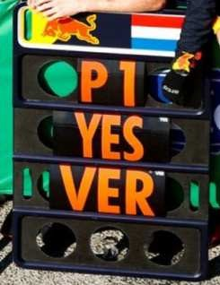
2 | S7687 | 1/43 | Alfa Romeo Racing ORLEN C41 No.88 Alfa Romeo Racing ORLEN Dutch GP  2021 | 9580006976871
 |  |  | Robert Kubica | JAN 2022
 |  |  | 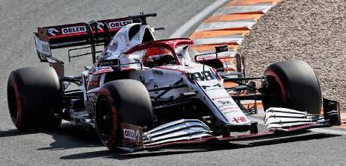
3 | S7688 | 1/43 | Alfa Romeo Racing ORLEN C41 No.99 Alfa Romeo Racing ORLEN Italian GP  2021 | 9580006976888
 |  |  | Antonio Giovinazzi | JAN 2022
 |  |  | 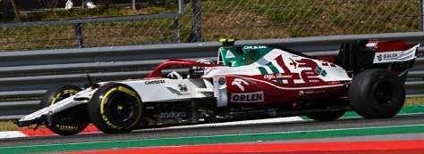
4 | S7689 | 1/43 | McLaren MCL35M No.3 McLaren Winner Italian GP 2021 | 9580006976895
 |  |  | Daniel Ricciardo | JAN 2022
 |  |  | With Pit Board
 |  |  | 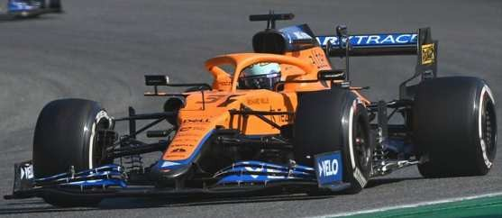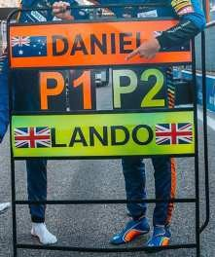

 | Item No. | Scale | Description | Information
5 | S7690 | 1/43 | McLaren MCL35M No.4 McLaren 2nd Italian GP 2021 | 9580006976901
 |  |  | Lando Norris | JAN 2022
 |  |  | With Pit Board
 |  |  | 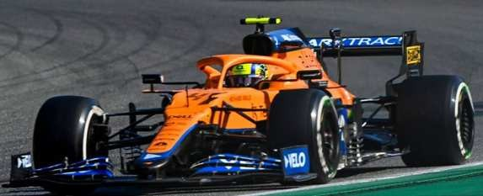
6 | S7691 | 1/43 | Mercedes-AMG Petronas Formula One Team No.77 W12 E Performance 3rd  Italian GP 2021 - 1st Sprint Race | 9580006976918
 |  |  | Valtteri Bottas | JAN 2022
 |  |  | 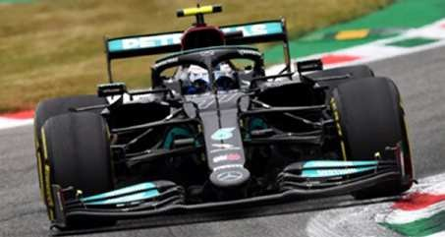
7 | S7692 | 1/43 | Aston Martin AMR21 No.5 Aston Martin Cognizant F1 Team Italian GP 2021 | 9580006976925
 |  |  | Sebastian Vettel | JAN 2022
 |  |  | 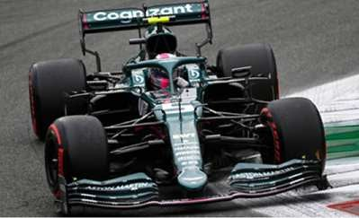
8 | S7693 | 1/43 | Aston Martin AMR21 No.18 Aston Martin Cognizant F1 Team Italian GP 2021 | 9580006976932
 |  |  | Lance Stroll | JAN 2022
 |  |  | 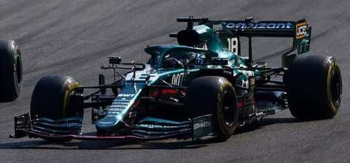
9 | S7694 | 1/43 | McLaren MCL35M No.3 Winner Italian GP 2021 + No.4 McLaren 2nd Italian  GP 2021 | 9580006976949
 |  |  | Daniel Ricciardo + Lando Norris | JAN 2022
 |  |  | With Pit Board
 |  |  | 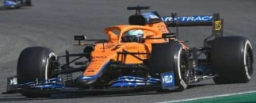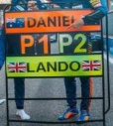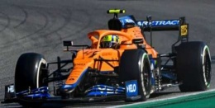 | Limited 1000

1:18th scale

 | Item No. | Scale | Description | Information
10 | 18S601 | 1/18 | Red Bull Racing Honda RB16B No.33 Red Bull Racing Winner Dutch GP  2021 | 9580006476012
 |  |  | Max Verstappen | APR 2022
 |  |  | With Pit Board
11 | 18S602 | 1/18 | McLaren MCL35M No.3 McLaren Winner Italian GP 2021 | 9580006476029
 |  |  | Daniel Ricciardo | APR 2022
 |  |  | With Pit Board
12 | 18S603 | 1/18 | Alfa Romeo Racing ORLEN C41 No.99 Alfa Romeo Racing ORLEN Italian GP  2021 | 9580006476036
 |  |  | Antonio Giovinazzi | APR 2022

END

