P&P Racing

Newsletter No. 24 - 2021

Issue Date: 24th September 2021

Subject: Pre-Order Notice Spark 1:43 Le Mans 24hr 2021

Please find below details of 46 forthcoming items and the anticipated release date.

To pre-order, please contact P&P Racing by no later than

18:00 hours on Tuesday 5th October 2021 – ACT NOW!

The cost of each model will be confirmed prior to placing an order on your behalf. Thank you!

 | Item No. | Scale | Description | Information
1 | 43LM21 | 1/43 | TOYOTA GR010 HYBRID No.7 TOYOTA GAZOO Racing Winner 24H Le  Mans 2021 | 9580006420213
 |  |  | M. Conway - K. Kobayashi - J. M. Lòpez | DEC 2021
 |  |  | 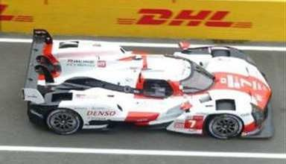
2 | S8231 | 1/43 | TOYOTA GR010 HYBRID No.8 TOYOTA GAZOO Racing 2nd 24H Le Mans  2021 | 9580006982315
 |  |  | S. Buemi - K. Nakajima - B. Hartley | DEC 2021
 |  |  | 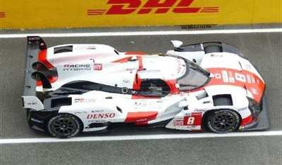
3 | S8232 | 1/43 | Alpine A480 - Gibson No.36 Alpine Elf Matmut 3rd 24H Le Mans 2021 | 9580006982322
 |  |  | A. Negrão - N. Lapierre - M. Vaxivière | DEC 2021
 |  |  | 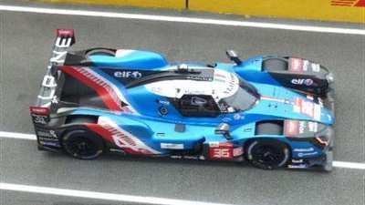
4 | S8233 | 1/43 | Glickenhaus 007 LMH No.708 Glickenhaus Racing 4th 24H Le Mans 2021 | 9580006982339
 |  |  | L-F. Derani - F. Mailleux - O. Pla | APR 2022
 |  |  | 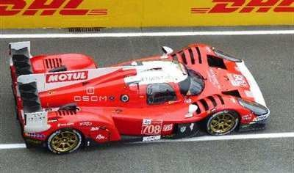
5 | S8234 | 1/43 | Glickenhaus 007 LMH No.709 Glickenhaus Racing 5th 24H Le Mans 2021 | 9580006982346
 |  |  | R. Briscoe - R. Westbrook - R. Dumas | APR 2022
 |  |  | 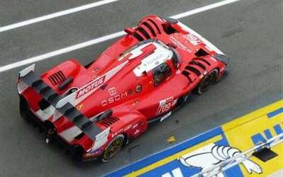

 | Item No. | Scale | Description | Information
6 | S8235 | 1/43 | Oreca 07 - Gibson No.1 Richard Mille Racing Team 24H Le Mans 2021 | 9580006982353
 |  |  | T. Calderón - S. Flörsch - B. Visser | MAR 2022
 |  |  | 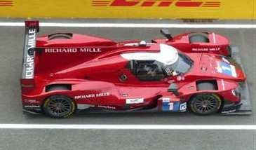
7 | S8236 | 1/43 | Oreca 07 - Gibson No.20 High Class Racing 24H Le Mans 2021 | 9580006982360
 |  |  | D. Andersen - R. Taylor - M. Sørensen | FEB 2022
 |  |  | 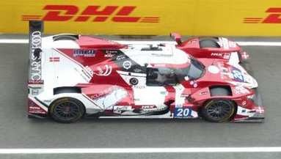
8 | S8237 | 1/43 | Oreca 07 - Gibson No.21 DragonSpeed USA Winner LMP2 Pro Am class 24H  Le Mans 2021 | 9580006982377
 |  |  | H. Hedman - B. Hanley - J-P. Montoya | APR 2022
 |  |  | 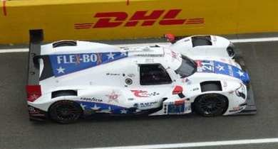
9 | S8238 | 1/43 | Oreca 07 - Gibson No.22 United Autosports USA 24H Le Mans 2021 | 9580006982384
 |  |  | P. Hanson - F. Scherer - F. Albuquerque | FEB 2022
 |  |  | 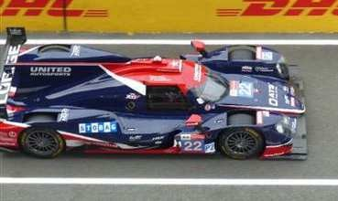
10 | S8239 | 1/43 | Oreca 07 - Gibson No.23 United Autosports 9th 24H Le Mans 2021 | 9580006982391
 |  |  | P. di Resta - A. Lynn - W. Boyd | APR 2022
 |  |  | 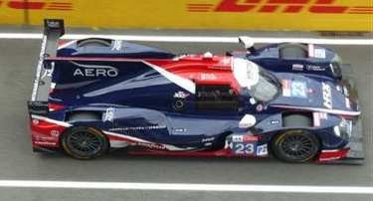
11 | S8240 | 1/43 | Oreca 07 - Gibson No.24 PR1 Motorsports Mathiasen 24H Le Mans 2021 | 9580006982407
 |  |  | P. Kelly - G. Aubry - S. Trummer | MAY 2022
 |  |  | 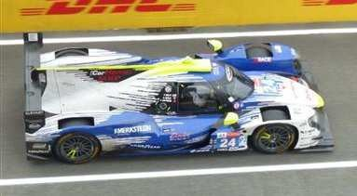

 | Item No. | Scale | Description | Information
12 | S8241 | 1/43 | Aurus 01 - Gibson No.25 G-Drive Racing 24H Le Mans 2021 | 9580006982414
 |  |  | J. Falb - R. Merhi - R. Andrade | MAY 2022
 |  |  | 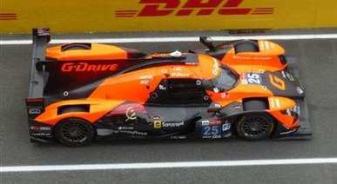
13 | S8242 | 1/43 | Aurus 01 - Gibson No.26 G-Drive Racing 24H Le Mans 2021 | 9580006982421
 |  |  | R. Rusinov - F. Colapinto - N. de Vries | MAY 2022
 |  |  | 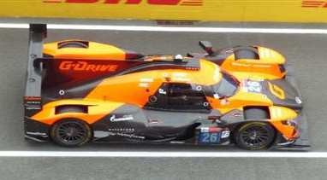
14 | S8243 | 1/43 | Oreca 07 - Gibson No.28 JOTA 2nd LMP2 class 24H Le Mans 2021 | 9580006982438
 |  |  | S. Gelael - S. Vandoorne - T. Blomqvist | JAN 2022
 |  |  | 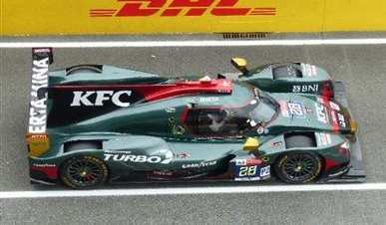
15 | S8244 | 1/43 | Oreca 07 - Gibson No.29 Racing Team Nederland 2nd LMP2 Pro Am class  24H Le Mans 2021 | 9580006982445
 |  |  | F. van Eerd - G. van der Garde - J. van Uitert | JAN 2022
 |  |  | 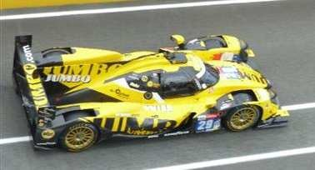
16 | S8245 | 1/43 | Oreca 07 - Gibson No.30 Duqueine Team 24H Le Mans 2021 | 9580006982452
 |  |  | R. Binder - G. Rojas - T. Gommedy | FEB 2022
 |  |  | 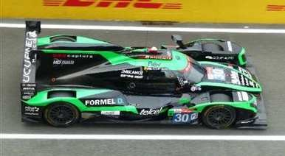
17 | S8246 | 1/43 | Oreca 07 - Gibson No.31 Team WRT Winner LMP2 class 24H Le Mans 2021 | 9580006982469
 |  |  | R. Frijns - F. Habsburg - C. Milesi | DEC 2021
 |  |  | 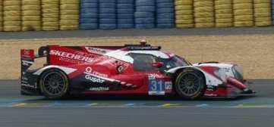

 | Item No. | Scale | Description | Information
18 | S8247 | 1/43 | Oreca 07 - Gibson No.32 United Autosports 24H Le Mans 2021 | 9580006982476
 |  |  | N. Jamin - J. Aberdein - M. Maldonado | DEC 2021
 |  |  | 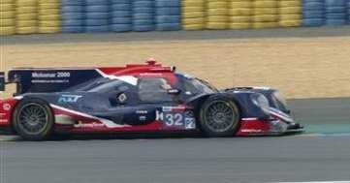
19 | S8248 | 1/43 | Oreca 07 - Gibson No.34 Inter Europol Competition 10th 24H Le Mans 2021 | 9580006982483
 |  |  | J. Śmiechowski - R. van der Zande - A. Brundle | JAN 2022
 |  |  | 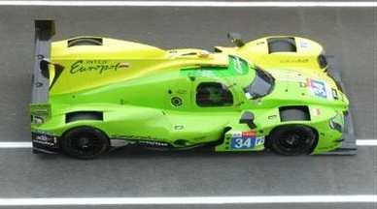
20 | S8249 | 1/43 | Oreca 07 - Gibson No.38 JOTA 1st Hyperpole LMP2 class 24H Le Mans 2021 | 9580006982490
 |  |  | R. Gonzales - A-F. da Costa - A. Davidson | FEB 2022
 |  |  | 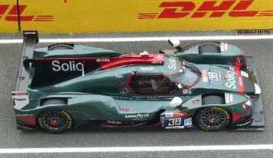
21 | S8250 | 1/43 | Oreca 07 - Gibson No.39 SO24-Dirob by Graff 24H Le Mans 2021 | 9580006982506
 |  |  | V. Capillaire - A. Robin - M. Robin | MAR 2022
 |  |  | 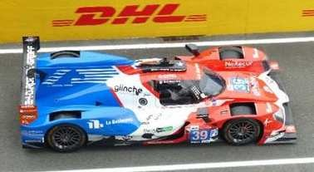
22 | S8251 | 1/43 | Oreca 07 - Gibson No.41 Team WRT 24H Le Mans 2021 | 9580006982513
 |  |  | R. Kubica - L. Delétraz - Y. Ye | DEC 2021
 |  |  | 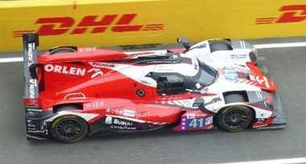
23 | S8252 | 1/43 | Oreca 07 - Gibson No.44 ARC Bratislava 24H Le Mans 2021 | 9580006982520
 |  |  | M. Konopka - O. Webb - M. Konopka | APR 2022
 |  |  | 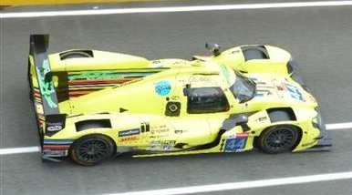

 | Item No. | Scale | Description | Information
24 | S8253 | 1/43 | Oreca 07 - Gibson No.48 IDEC Sport 24H Le Mans 2021 | 9580006982537
 |  |  | P. Lafargue - P-L. Chatin - P. Pilet | DEC 2021
 |  |  | 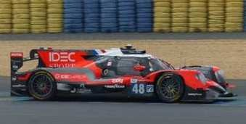
25 | S8254 | 1/43 | Oreca 07 - Gibson No.49 High Class Racing 24H Le Mans 2021 | 9580006982544
 |  |  | A. Fjordbach - J. Magnussen - K. Magnussen | APR 2022
 |  |  | 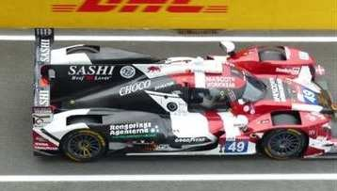
26 | S8255 | 1/43 | Oreca 07 - Gibson No.65 Panis Racing 3rd LMP2 class 24H Le Mans 2021 | 9580006982551
 |  |  | J. Canal - W. Stevens - J. Allen | MAR 2022
 |  |  | 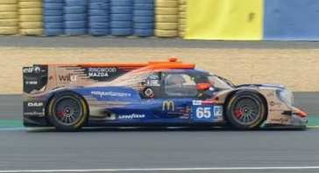
27 | S8256 | 1/43 | Oreca 07 - Gibson No.70 Realteam Racing 3rd LMP2 Pro Am class 24H Le  Mans 2021 | 9580006982568
 |  |  | E. Garcia - L. Duval - N. Nato | APR 2022
 |  |  | 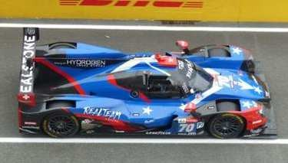
28 | S8257 | 1/43 | Ligier JS P217 - Gibson No.74 Racing Team India Eurasia 24H Le Mans 2021 | 9580006982575
 |  |  | J. Winslow - J. Corbett - T. Cloet | FEB 2022
 |  |  | 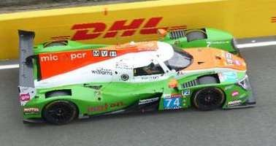
29 | S8258 | 1/43 | Oreca 07 - Gibson No.82 Risi Competizione 24H Le Mans 2021 | 9580006982582
 |  |  | R. Cullen - O. Jarvis - F. Nasr | FEB 2022
 |  |  | 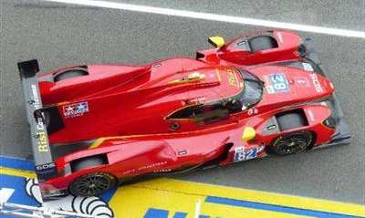

 | Item No. | Scale | Description | Information
30 | S8259 | 1/43 | Chevrolet Corvette C8.R No.63 Corvette Racing 2nd LMGTE Pro class 24H  Le Mans 2021 | 9580006982599
 |  |  | A. Garcia - J. Taylor - N. Catsburg | DEC 2021
 |  |  | 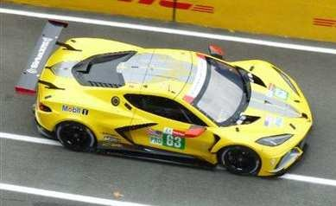
31 | S8260 | 1/43 | Chevrolet Corvette C8.R No.64 Corvette Racing 24H Le Mans 2021 | 9580006982605
 |  |  | T. Milner - N. Tandy - A. Sims | DEC 2021
 |  |  | 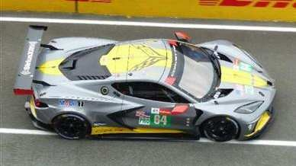
32 | S8261 | 1/43 | Porsche 911 RSR-19 No.72 Hub Auto Racing 1st Hyperpole LMGTE Pro  class 24H Le Mans 2021 | 9580006982612
 |  |  | D. Vanthoor - A. Parente - M. Martin | DEC 2021
 |  |  | 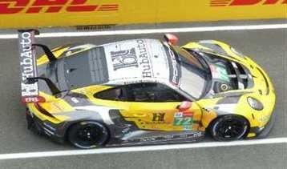
33 | S8262 | 1/43 | Porsche 911 RSR-19 No.79 WeatherTech Racing 24H Le Mans 2021 | 9580006982629
 |  |  | C. MacNeil - E. Bamber - L. Vanthoor | FEB 2022
 |  |  | 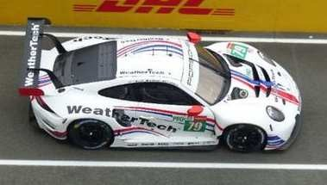
34 | S8265 | 1/43 | Porsche 911 RSR-19 No.18 Absolute Racing 24H Le Mans 2021 | 9580006982650
 |  |  | A. Haryanto - A. Picariello - M. Seefried | DEC 2021
 |  |  | 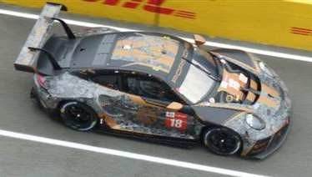
35 | S8266 | 1/43 | Aston Martin Vantage AMR No.33 TF Sport 2nd LMGTE Am class 24H Le  Mans 2021 | 9580006982667
 |  |  | B. Keating - D. Pereira - F. Fraga | DEC 2021
 |  |  | 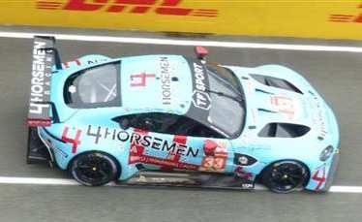

 | Item No. | Scale | Description | Information
36 | S8267 | 1/43 | Porsche 911 RSR-19 No.46 Team Project 1 24H Le Mans 2021 | 9580006982674
 |  |  | D. Olsen - A. Buchardt - R. Foley | FEB 2022
 |  |  | 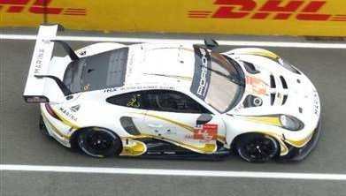
37 | S8268 | 1/43 | Porsche 911 RSR-19 No.56 Team Project 1 24H Le Mans 2021 | 9580006982681
 |  |  | E. Perfetti - M. Cairoli - R. Pera | FEB 2022
 |  |  | 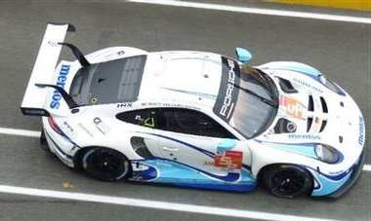
38 | S8269 | 1/43 | Porsche 911 RSR-19 No.69 Herberth Motorsport 24H Le Mans 2021 | 9580006982698
 |  |  | R. Renauer - R. Bohn - R. Ineichen | MAR 2022
 |  |  | 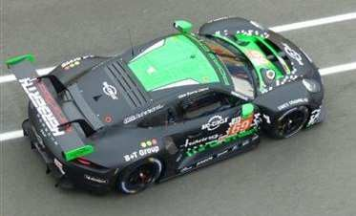
39 | S8270 | 1/43 | Porsche 911 RSR-19 No.77 Dempsey-Proton Racing 24H Le Mans 2021 | 9580006982704
 |  |  | C. Ried - J. Evans - M. Campbell | FEB 2022
 |  |  | 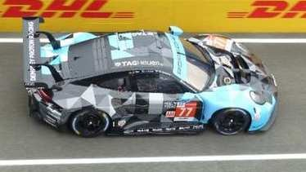
40 | S8271 | 1/43 | Porsche 911 RSR-19 No.86 GR Racing 24H Le Mans 2021 | 9580006982711
 |  |  | M. Wainwright - B. Barker - T. Gamble | MAR 2022
 |  |  | 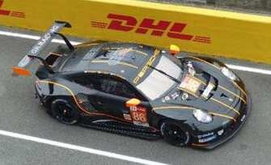
41 | S8272 | 1/43 | Porsche 911 RSR-19 No.88 Dempsey-Proton Racing 1st Hyperpole LMGTE  Am class 24H Le Mans 2021 | 9580006982728
 |  |  | J. Andlauer - D. Bastien - L-D. Arnold | APR 2022
 |  |  | 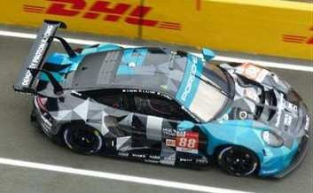

 | Item No. | Scale | Description | Information
42 | S8273 | 1/43 | Aston Martin Vantage AMR No.95 TF Sport 24H Le Mans 2021 | 9580006982735
 |  |  | J. Hartshorne - O. Hancock - R. Gunn | MAR 2022
 |  |  | 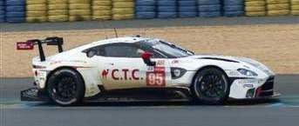
43 | S8274 | 1/43 | Aston Martin Vantage AMR No.98 Aston Martin Racing 24H Le Mans 2021 | 9580006982742
 |  |  | P. Dalla Lana - N. Thiim - M. Gomes | JAN 2022
 |  |  | 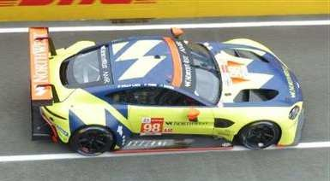
44 | S8275 | 1/43 | Porsche 911 RSR-19 No.99 Proton Racing 24H Le Mans 2021 | 9580006982759
 |  |  | H. Tincknell - V. Inthraphuvasak - F. Latorre | FEB 2022
 |  |  | 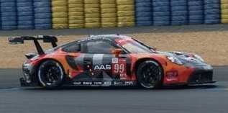
45 | S8276 | 1/43 | Aston Martin Vantage AMR No.777 D'Station Racing 24H Le Mans 2021 | 9580006982766
 |  |  | S. Hoshino - T. Fujii - A. Watson | APR 2022
 |  |  | 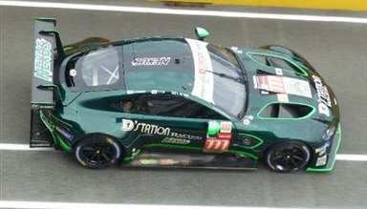
46 | S8277 | 1/43 | Oreca 07 - Gibson No.84 Association SRT41 24H Le Mans 2021 | 9580006982773
 |  |  | T. Aoki - N. Bailly - M. Lahaye | APR 2022
 |  |  | 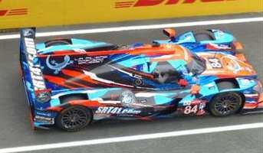

END

