P&P Racing

Newsletter No. 25 - 2021

Issue Date: 4th October 2021

Subject: Pre-Order Notice - Minichamps F1 2021 1:43 & 1:18

Please find below details of 17 forthcoming items and the anticipated release date.

To pre-order, please contact P&P Racing by no later than

18:00 hours on Thursday 14th October 2021 ACT NOW!

The cost of each model will be confirmed prior to placing an order on your behalf. Thank you!

1:18 DIE CAST
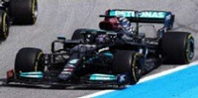 | 110211144 | MERCEDES-AMG PETRONAS FORMULA ONE  TEAM W12 E PERFORMANCE – HAMILTON -  WINNER BRITISH GP 2021 | 1:18 | Q2/2022
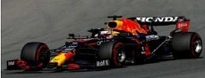 | 110211333 | RED BULL RACING HONDA RB16B – MAX  VERSTAPPEN – WINNER BELGIAN GP 2021 | 1:18 | Q2/2022
 | 110211433 | RED BULL RACING HONDA RB16B – MAX  VERSTAPPEN – WINNER DUTCH GP 2021 | 1:18 | Q2/2022
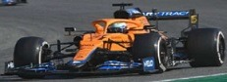 | 530213303 | MCLAREN F1 TEAM MCL35M – DANIEL RICCIARDO – WINNER ITALIAN GP 2021 | 1:18 | Q2/2022
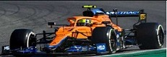 | 530213304 | MCLAREN F1 TEAM MCL35M – LANDO NORRIS  2ND PLACE ITALIAN GP 2021 | 1:18 | Q2/2022
1:18 RESIN
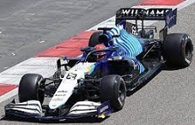 | 117211363 | WILLIAMS RACING MERCEDES FW43B – GEORGE RUSSELL – 2ND BELGIAN GP 2021 | 1:18 | Q2/2022
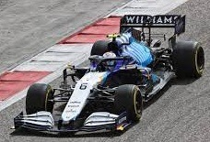 | 117211306 | WILLIAMS RACING MERCEDES FW43B -  NICHOLAS LATIFI- BELIAN GP 2021 | 1:18 | Q2/2022
1:43 DIE CAST
 | 410211144 | MERCEDES-AMG PETRONAS FORMULA ONE  TEAM W12 E PERFORMANCE – HAMILTON -  WINNER BRITISH GP 2021 | 1:43 | Q2/2022
 | 410211333 | RED BULL RACING HONDA RB16B – MAX  VERSTAPPEN – WINNER BELGIAN GP 2021 | 1:43 | Q2/2022
 | 410211433 | RED BULL RACING HONDA RB16B – MAX  VERSTAPPEN – WINNER DUTCH GP 2021 | 1:43 | Q2/2022
1:43 RESIN
 | 417211306 | WILLIAMS RACING MERCEDES FW43B -  NICHOLAS LATIFI - BELGIAN GP 2021 | 1:43 | Q2/2022
 | 417211363 | WILLIAMS RACING MERCEDES FW43B - GEORGE RUSSELL - 2ND PLACE BELGIAN GP 2021 | 1:43 | Q2/2022
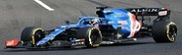 | 417211214 | ALPINE F1 TEAM A521 - FERNANDO ALONSO -  HUNGARIAN GP 2021 | 1:43 | Q2/2022
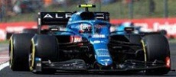 | 417211231 | ALPINE F1 TEAM A521 - ESTEBAN OCON -  WINNER HUNGARIAN GP 2021 | 1:43 | Q2/2022
 | 537215804 | MCLAREN F1 TEAM MCL35M - LANDO NORRIS  ITALIAN GP 2021 | 1:43 | Q2/2022
 | 537215803 | MCLAREN F1 TEAM MCL35M - DANIEL RICCIARDO - WINNER ITALIAN GP 2021 | 1:43 | Q2/2022
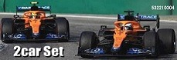 | 532210304 | 2-CAR SET - MCLAREN F1 TEAM MCL35M - 1-2  FINISH RICCIARDO/NORRIS - ITALIAN GP 2021 | 1:43 | Q2/2022

Please note the different sections relating to die-cast and resin models.
END

