P&P Racing

Newsletter No. 28 - 2021

Issue Date: 31st October 2021

Subject: Pre-Order Notice – Spark 1:43 various including classic F1

Please find below details of 49 forthcoming items and the anticipated release date.

To pre-order, please contact P&P Racing by no later than

18:00 hours on Sunday 21st November 2021 ACT NOW!

The cost of each model will be confirmed prior to placing an order on your behalf

Ref | Description | Barcode | Due (2022)
43SE67 | Ford GT40 Mk IV No.1 Winner Sebring 12H 1967 | 9580006120670 | Feb
 | M. Andretti - B. McLaren
 | 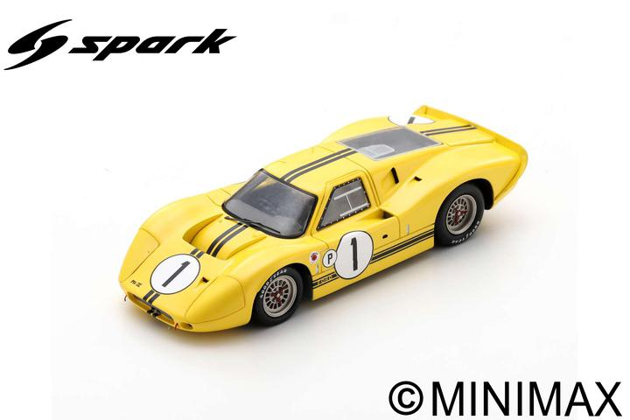
S0847 | Meyers Manx Buggy 1964 | 9580006908476 | Feb
 | 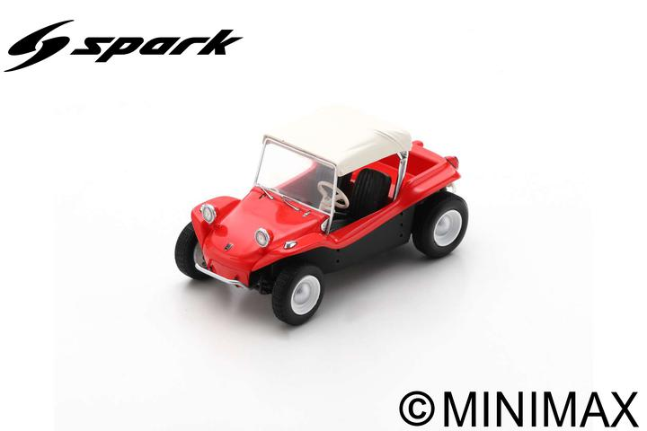
S1947 | Porsche 787 No.7 Dutch GP 1961 | 9580006919472 | Feb
 | Dan Gurney
 | 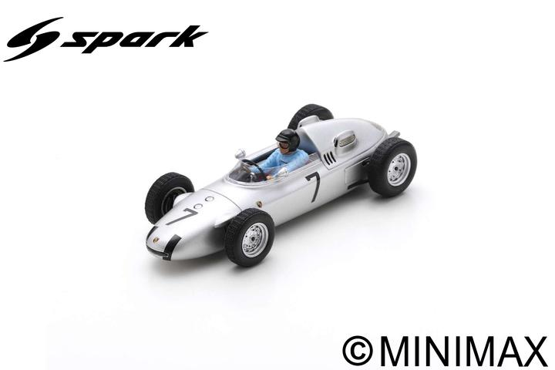
S1948 | Porsche 787 No.15 Dutch GP 1962 | 9580006919489 | Jan
 | Ben Pon
 | 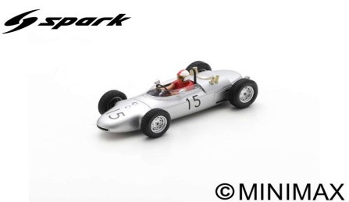
S2338 | Porsche 908/3 No.10 500km Dijon 1976 | 9580006923387 | Feb
 | B. Wollek - H. Godel
 | 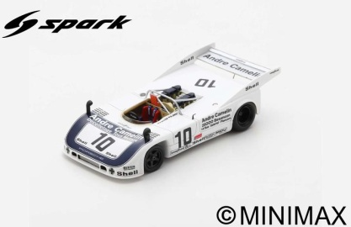
S2448 | Aston Martin DB3 No.30 2nd Sebring 12H 1953 | 9580006924483 | Feb
 | R. Parnell - G. Abecassis
 | 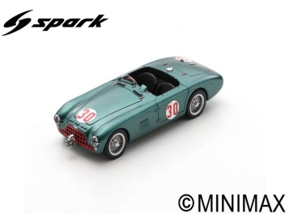
S2780 | Toleman TG184 No.20 US GP 1984 | 9580006927804 | Mar
 | Johnny Cecotto
 | 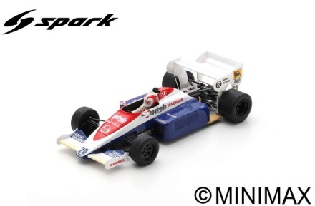
S2784 | Toleman TG184 No.19 3rd Portugal GP 1984 | 9580006927842 | Feb
 | Ayrton Senna
 | 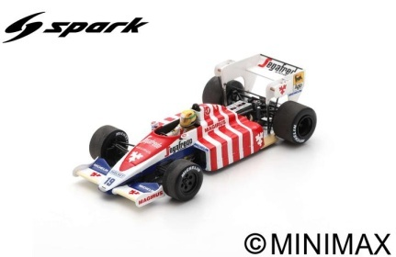
S3543 | Cougar C28LM No.54 6th 24H Le Mans 1992 | 9580006935434 | Feb
 | H. Pescarolo - B. Wollek - J-L. Ricci
 | 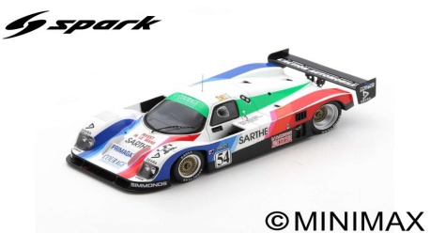
S3547 | Matra-Simca MS 650 No.33 4th 24H Le Mans 1969 | 9580006935472 | Feb
 | J-P. Beltoise - P. Courage
 | 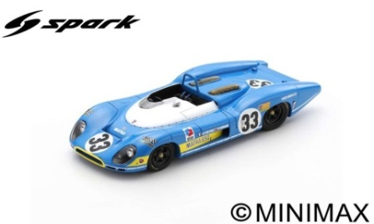
S3948 | Ensign N180B No.14 6th Dutch GP 1981 | 9580006939487 | Mar
 | Eliseo Salazar
 | 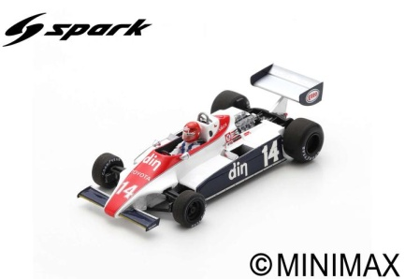
S3994 | Surtees TS9B No.26 4th Spanish GP 1972 | 9580006939944 | Feb
 | Andrea de Adamich
 | 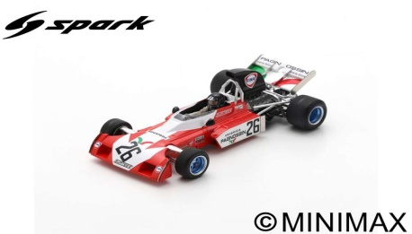
S3999 | Surtees TS9B No.23 Brazil GP 1973 | 9580006939999 | Mar
 | Luiz Bueno
 | 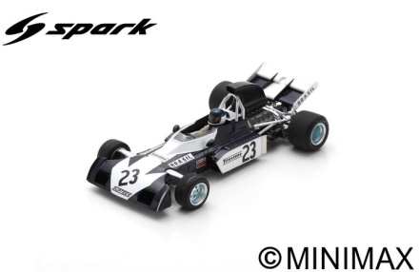
S5537 | Citroën DS No.106 Rallye Dakar 1980 | 9580006955371 | Mar
 | Bertrand Roncin - Benoît Bizet
 | 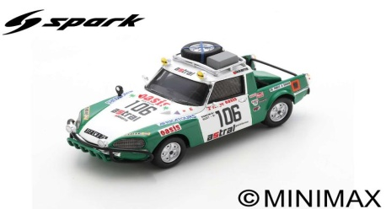
S5545 | Citroën DS Break Ligier Assistance 1976 | 9580006955456 | Feb
 | 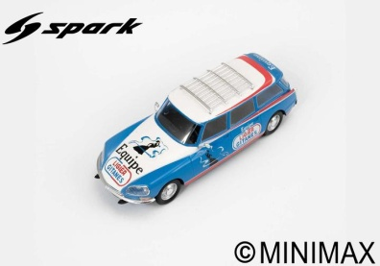
S5690 | Alpine A210 No.49 10th 24H Le Mans 1967 | 9580006956903 | Feb
 | A. de Cortanze - A. Le Guellec
 | 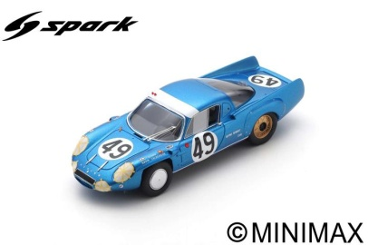
S5720 | BRM P25 No.23 British GP 1956 | 9580006957207 | Feb
 | Mike Hawthorn
 | 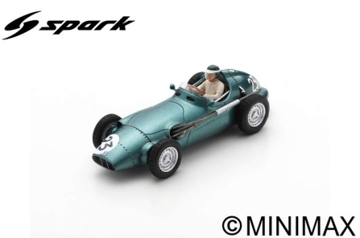
S5721 | BRM P25 No.24 British GP 1956 | 9580006957214 | Mar
 | Tony Brooks
 | 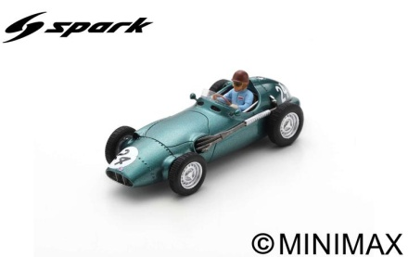
S5730 | BRM P25 No.6 2nd British GP 1959 | 9580006957306 | Feb
 | Stirling Moss
 | 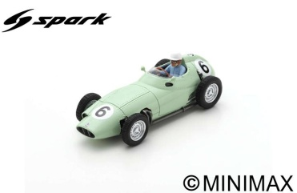
S5771 | Vollstedt No.21 Riverside 1967 | 9580006957719 | Feb
 | Jim Clark
 | 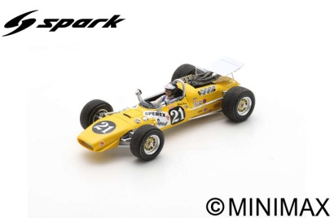
S5786 | Arrows A6 No.30 Belgian GP 1983 | 9580006957863 | Feb
 | Thierry Boutsen
 | 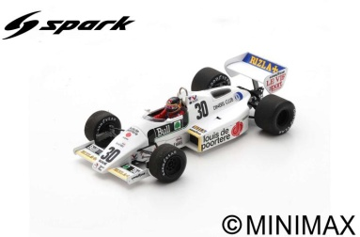
S5792 | Arrows A6 No.29 German GP 1983 | 9580006957924 | Mar
 | Marc Surer
 | 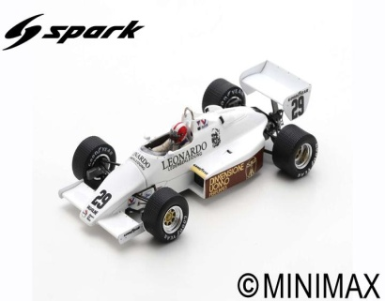
S6030 | Renault 5 Alpine Gr2 No.19 2nd Rally Monte Carlo 1978 | 9580006960306 | Mar
 | Jean Ragnotti - Jean-Marc Andrié
 | 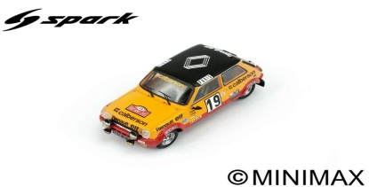
S6035 | Renault 5 Alpine Gr2 No.12 3rd Rally Monte Carlo 1978 | 9580006960351 | Feb
 | Guy Fréquelin - Jacques Delaval
 | 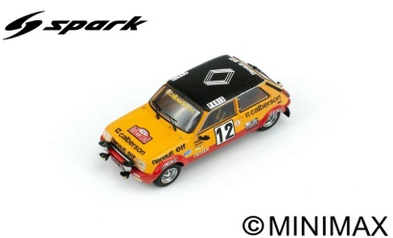
S6195 | Renault 16 Assistance Rally | 9580006961952 | Feb
 | 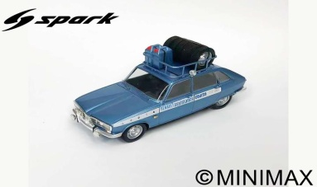
S6253 | Toyota 92C-V No.99 Suzuka Test 1992 | 9580006962539 | Feb
 | G. Fouche - S. Andskar
 | 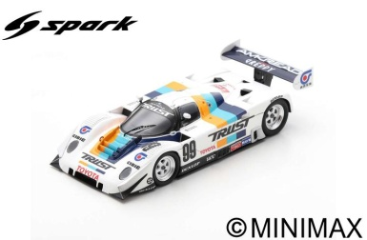
S6284 | Datsun 240 Z No.20 29th Rally Monte Carlo 1972 | 9580006962843 | Feb
 | Tony Fall - Mike Wood
 | 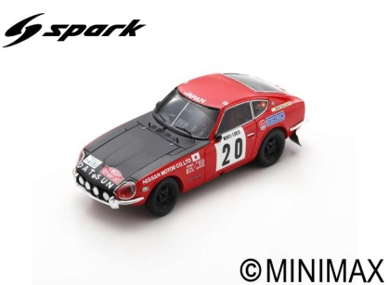
S6419 | BMW M1 Gr.5 No.81 9H Kyalami 1982 | 9580006964199 | Feb
 | U. Grano - E. Joosen - E. Calderari
 | 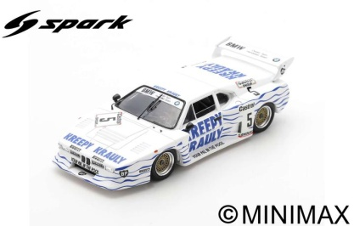
S6633 | Porsche 911 Carrera RS 3.0 No.23 7th Rally Monte Carlo 1976 | 9580006966339 | Jan
 | Guy Fréquelin - Jacques Delaval
 | 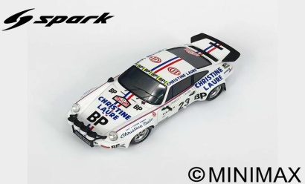
S6977 | Tyrrell 024 No.19 Monaco GP 1996 | 9580006969774 | Mar
 | Mika Salo
 | 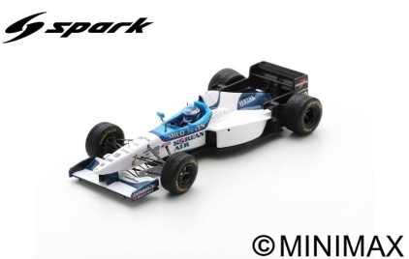
S6987 | Cooper T86B No.16 British GP 1968 | 9580006969873 | Mar
 | Robin Widdows
 | 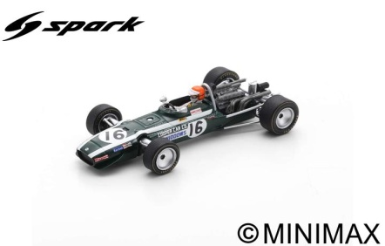
S7206 | Vanwall VW5 No.26 Winner Pescara GP 1957 | 9580006972064 | Mar
 | Stirling Moss
 | 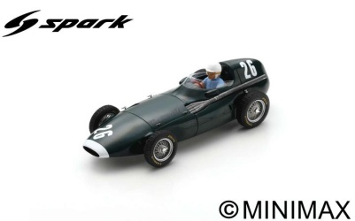
S7211 | Penske PC3 No.39 Dutch GP 1976 | 9580006972118 | Mar
 | Boy Hayje
 | 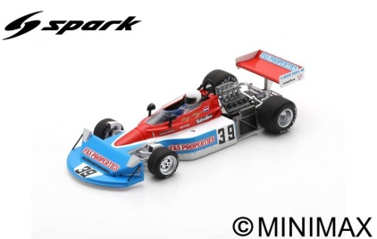
S7252 | Osella FA1B No.31 Belgian GP 1981 | 9580006972521 | Mar
 | Piercarlo Ghinzani
 | 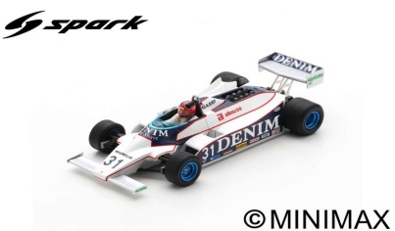
S7253 | Osella FA1B No.31 San Marino GP 1981 | 9580006972538 | Feb
 | Miguel Angel Guerra
 | 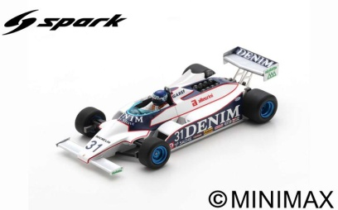
S7283 | Tyrrell 011 No.3 4th German GP 1982 | 9580006972835 | Mar
 | Michele Alboreto
 | 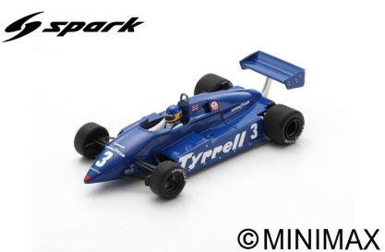
S7284 | Tyrrell 011 No.4 Italian GP 1982 | 9580006972842 | Feb
 | Brian Henton
 | 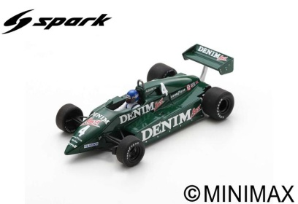
S7295 | Lotus 72D No.12 US GP 1972 | 9580006972958 | Feb
 | Reine Wisell
 | 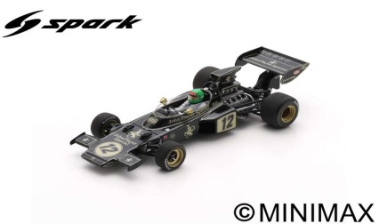
S7444 | Brabham BT60B No.8 British GP 1992 | 9580006974440 | Feb
 | Damon Hill
 | 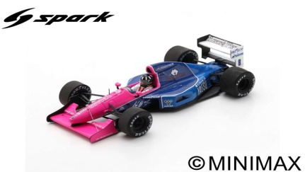
S7576 | Iso IR No.26 Canadian GP 1973 | 9580006975768 | Mar
 | Tim Schenken
 | 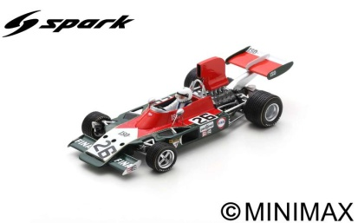
S7829 | Peugeot 202 U "Peugeot Service" | 9580006978295 | Feb
 | 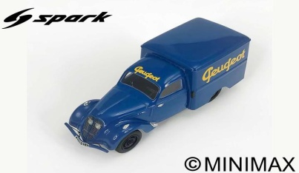
S8200 | Lotus Elite No.38 24H Le Mans 1959 | 9580006982001 | Jan
 | J.F. Malle - J.C. Vidilles
 | 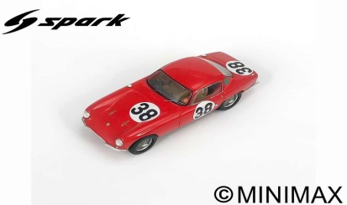
S8498 | Porsche 911 GT3 Cup No.1 Porsche Carrera Cup Scandinavia Champion 2020 | 9580006984982 | Feb
 | Lukas Sundahl
 | 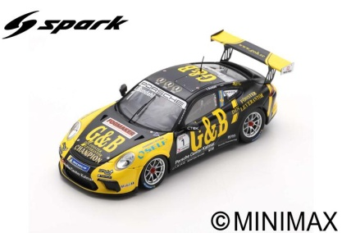
S8506 | Porsche 911 GT3 Cup No.25 Porsche Supercup Champion 2020 | 9580006985064 | Feb
 | Larry ten Voorde
 | 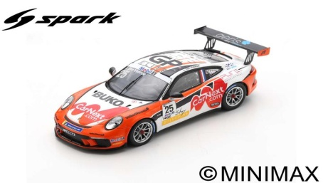
S8606 | Lola T600 No.17 24H Le Mans 1981 | 9580006986061 | Feb
 | B. Redman - B. Rahal
 | 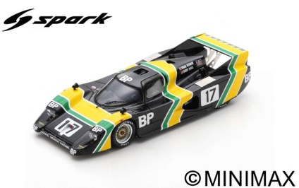
S9201 | McLaren 720S GT3 No.16 - Teo Martín Motorsport | 9580006992017 | Jan
 | International GT Open 2019
 | M. Hahn - A. Khodair - B. Barnicoat
 | 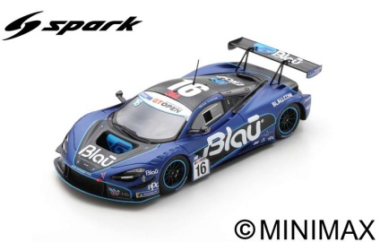
S9728 | Porsche RS 60 No.33 24H Le Mans 1960 | 9580006997289 | Jan
 | J. Bonnier - G. Hill
 | 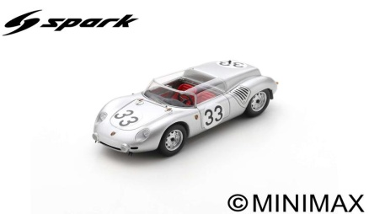
S9858 | Porsche 956 No.11 6th 24H Le Mans 1984 | 9580006998583 | Jan
 | A. Jones - V. Schuppan - J-P. Jarrier
 | 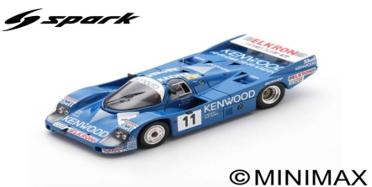
S9985 | Porsche 917K No.18 Le Mans Test 1971 | 9580006999856 | Jan
 | Jackie Oliver
 | 