P&P Racing

Newsletter No. 30 - 2021

Issue Date: 14th December 2021

Subject: Pre-Order Notice – Spark F1 End of Season Specials – VARIOUS SCALES

Please find below details of forthcoming items and the anticipated release date.

To pre-order, please contact P&P Racing by no later than

18:00 hours on Sunday 9th January 2022 ACT NOW!

The cost of each model will be confirmed prior to placing an order on your behalf

1:43rd SCALE

Ref | Description | Barcode | Available Month
S7850 | Red Bull Racing Honda RB16B No.11 Red Bull Racing | 9580006978509 | Mar
 | 3rd Mexican GP
 | Sergio Perez
 | With No.3 Board
 | 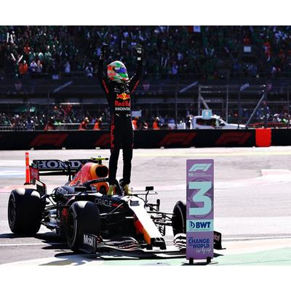
S7851 | Alpine A521 No.14 Alpine F1 Team | 9580006978516 | Mar
 | 3rd Qatar GP 2021
 | Fernando Alonso
 | With No.3 Board and Pit Board
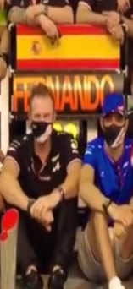
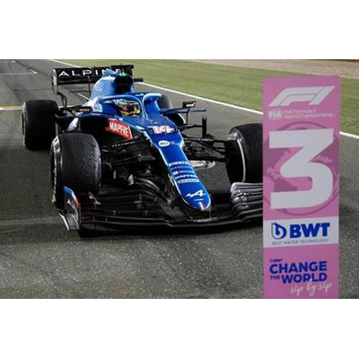
S7852 | Alpine A521 No.31 Alpine F1 Team | 9580006978523 | Apr
 | 4th Saudi Arabian GP 2021
 | Esteban Ocon
 | 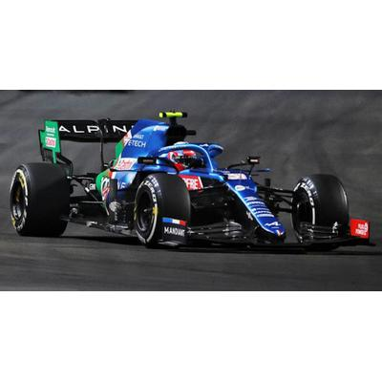
S7853 | AlphaTauri AT02 No.22 Scuderia AlphaTauri | 9580006978530 | Apr
 | 4th Abu Dhabi GP 2021
 | Yuki Tsunoda
 | 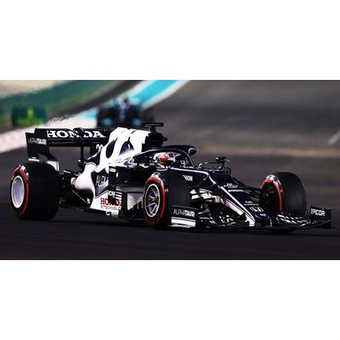
S7854 | McLaren MCL35M No.3 McLaren | 9580006978547 | Apr
 | Abu Dhabi GP 2021
 | Daniel Ricciardo
 | 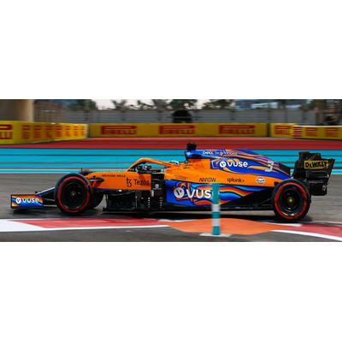
S7855 | McLaren MCL35M No.4 McLaren | 9580006978554 | Apr
 | Abu Dhabi GP 2021
 | Lando Norris
 | 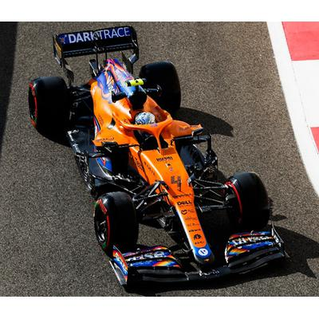
S7856 | Alfa Romeo Racing ORLEN C41 No.7 Alfa Romeo Sauber F1 Team | 9580006978561 | Apr
 | Abu Dhabi GP 2021
 | Kimi Räikkönen
 | 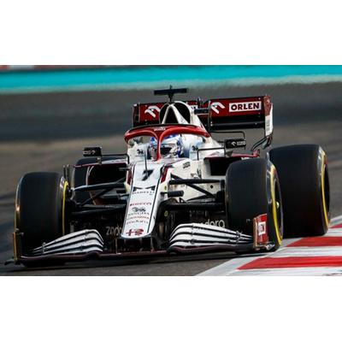
S7857 | Alfa Romeo Racing ORLEN C41 No.99 Alfa Romeo Racing ORLEN | 9580006978578 | Apr
 | Abu Dhabi GP 2021
 | Antonio Giovinazzi
 | 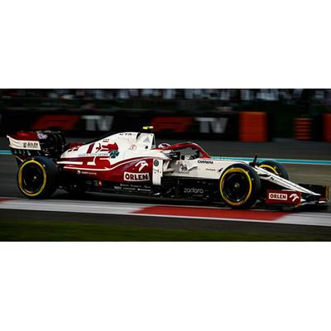
S7858 | Alpine A521 No.14 Alpine F1 Team | 9580006978585 | Apr
 | 8th Abu Dhabi GP 2021
 | Fernando Alonso
 | 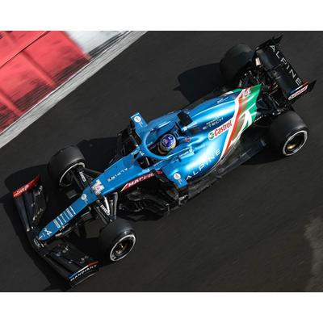
S7859 | Aston Martin AMR21 No.18 Aston Martin Cognizant F1 Team | 9580006978592 | Apr
 | Abu Dhabi GP 2021
 | Lance Stroll
 | 100th GP
 | 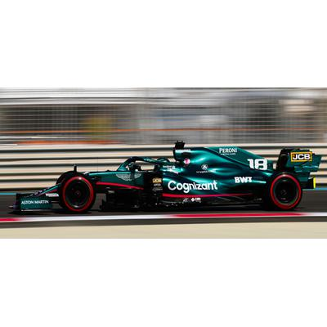
S7860 | Mercedes-AMG Petronas Formula One Team No.44 + No.77 W12 E Performance | 9580006978608 | Apr
 | 2nd Abu Dhabi GP 2021 + 6th Abu Dhabi GP 2021
 | Lewis Hamilton + Valtteri Bottas
 | Formula 1 Constructor's Champion 2021
 | Limited 500
 | 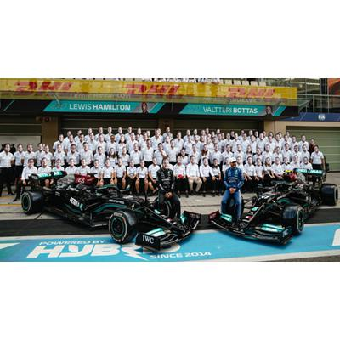
S7861 | Red Bull Racing Honda RB16B No.33 Red Bull Racing | 9580006978615 | Apr
 | Winner Abu Dhabi GP 2021
 | World Champion Edition With No.1 Board and Pit Board
 | Max Verstappen
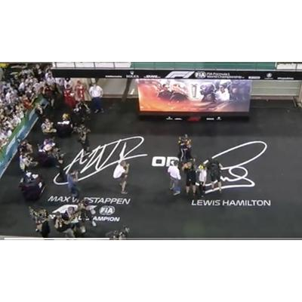
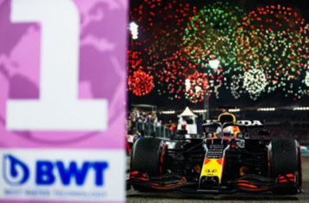

1:18th SCALE

Ref | Description | Barcode | Available Month
18S607 | Alfa Romeo Racing ORLEN C41 No.7 Alfa Romeo Sauber F1 Team | 9580006476074 | Jun
 | Abu Dhabi GP 2021
 | Kimi Räikkönen
18S608 | McLaren MCL35M No.4 McLaren | 9580006476081 | Jun
 | Abu Dhabi GP 2021
 | Lando Norris
18S609 | Red Bull Racing Honda RB16B No.33 Red Bull Racing | 9580006476098 | Jun
 | Winner Abu Dhabi GP 2021
 | World Champion Edition With No.1 Board and Pit Board
 | Max Verstappen
 | With Acrylic Cover

1:5th SCALE

Ref | Description | Barcode | Available Month
5HF070 | Mercedes-AMG - Abu Dhabi GP 2021 - Lewis Hamilton | 9580006190703 | May
 | 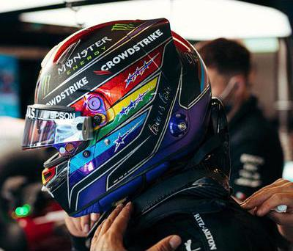

END

