P&P Racing

Newsletter No. 4 - 2022

Issue Date: 31st January 2022

Subject: Pre-Order Notice – Spark 1:43 Monte Carlo Rally 2022

Please find below details of forthcoming items and the anticipated release date.

To pre-order, please contact P&P Racing by no later than

18:00 hours on Tuesday 22nd February 2022 ACT NOW!

The cost of each model will be confirmed prior to placing an order on your behalf

Thank You

Ref | Description | Barcode | Available Month
S6697 | Ford Puma Rally1 No.19 M-SPORT Ford World Rally Team | 9580006966971 | Jul
 | Winner Rally Monte Carlo 2022
 | Sébastien Loeb - Isabelle Galmiche
 | 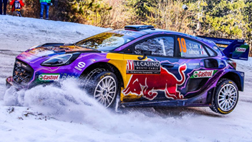
S6690 | TOYOTA GR Yaris Rally1 No.1 TOYOTA GAZOO Racing WRT | 9580006966902 | Aug
 | 2nd Rally Monte Carlo 2022
 | Sébastien Ogier - Benjamin Veillas
 | 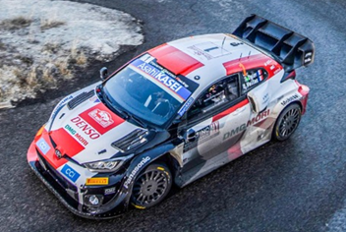
S6694 | Ford Puma Rally1 No.42 M-SPORT Ford World Rally Team | 9580006966940 | Aug
 | 3rd Rally Monte Carlo 2022
 | Craig Breen - Paul Nagle
 | 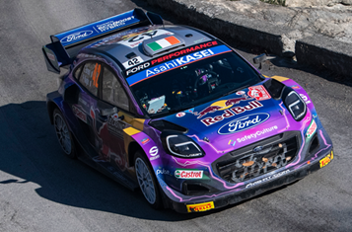
S6698 | Alpine A110 Rally No.46 Rally Monte Carlo 2022 | 9580006966988 | Jun
 | Manu Guigou - Kévin Bronner
 | 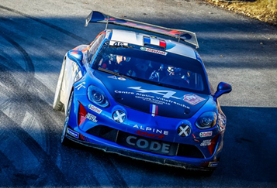
S6699 | Alpine A110 Rally No.47 Rally Monte Carlo 2022 | 9580006966995 | Jun
 | François Delecour - Jean-Rodolphe Guigonnet
 | 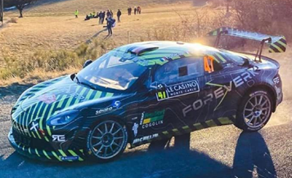
S6701 | Abarth 124 Rally RGT No.49 Rally Monte Carlo 2022 | 9580006967015 | Jun
 | Martin Rada - Jaroslav Jugas
 | 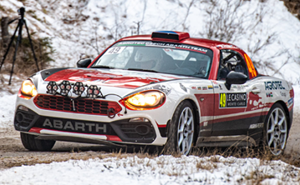
S6700 | Alpine A110 Rally No.48 Rally Monte Carlo 2022 | 9580006967008 | Jul
 | Raphaël Astier - Frédéric Vauclare
 | 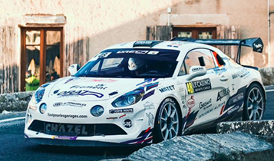
S6691 | TOYOTA GR Yaris Rally1 No.33 TOYOTA GAZOO Racing WRT | 9580006966919 | Aug
 | Rally Monte Carlo 2022
 | Elfyn Evans - Scott Martin
 | 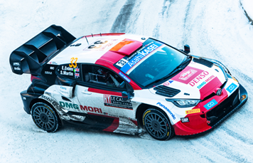
S6692 | TOYOTA GR Yaris Rally1 No.69 TOYOTA GAZOO Racing WRT | 9580006966926 | Sep
 | Rally Monte Carlo 2022
 | Kalle Rovanperä - Jonne Halttunen
 | 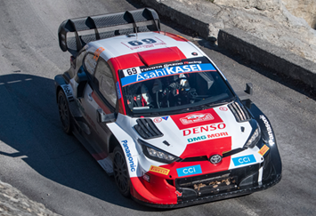
S6693 | TOYOTA GR Yaris Rally1 No.18 TOYOTA GAZOO Racing WRT NG | 9580006966933 | Sep
 | Rally Monte Carlo 2022
 | Takamoto Katsuta - Aaron Johnston
 | 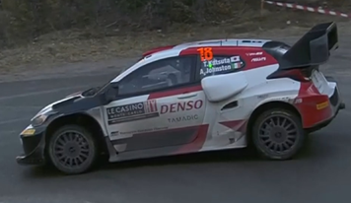
S6695 | Ford Puma Rally1 No.44 M-SPORT Ford World Rally Team | 9580006966957 | Sep
 | Rally Monte Carlo 2022
 | Gus Greensmith - Jonas Andersson
 | 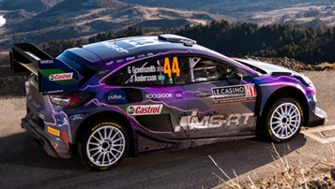
S6696 | Ford Puma Rally1 No.16 M-SPORT Ford World Rally Team | 9580006966964 | Sep
 | Rally Monte Carlo 2022
 | Adrien Fourmaux - Alexandre Coria
 | 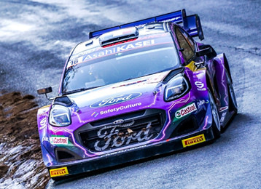
S6702 | Alpine A110 Rally No.50 Rally Monte Carlo 2022 | 9580006967022 | Sep
 | Ian Crerar - Élise Racette
 | 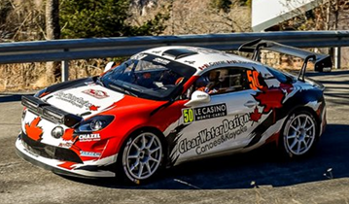
S6703 | Abarth 124 Rally RGT No.51 Rally Monte Carlo 2022 | 9580006967039 | Sep
 | Alberto Sassi - Gabriele Romei
 | 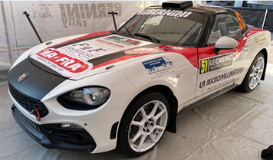
S6704 | Abarth 124 Rally RGT No.52 Rally Monte Carlo 2022 | 9580006967046 | Sep
 | Roberto Gobbin - Fabio Grimaldi
 | 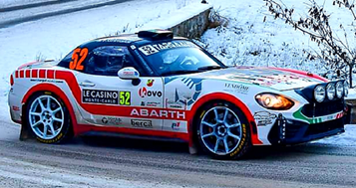
S6705 | Alpine A110 Rally No.53 Rally Monte Carlo 2022 | 9580006967053 | Sep
 | Christophe Casanova - Dominique Corvi
 | 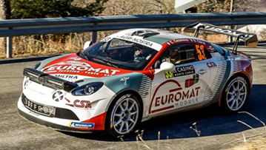

END

